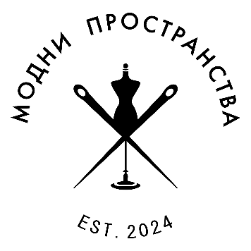
Fashion Spaces Foundation
Event: Fashion, classics and prosecco
Date: 17th and 18th of May 2025
Location: Philharmonic Hall / Ruse
About: After the success of the first of its kind event for Ruse in December 2024 – Fashion, jazz and hot wine, this time “Fashion Spaces Foundation“ has prepared a Spring event of a bigger scale. The name is Fashion, Classics and Prosecco and it will take place on 17th and 18th of May at the Philharmonic Hall in Ruse.
The event is unique for the town not only because it aims to unite and make popular the independent Ruse fashion designers and studios, but with the collaboration with Union Dynamics, to support a social cause for economic independence of women and children victims of home violence and to encourage the interest, imagination and talents of the youngest in the field of fashion, design, arts and handcrafts.
The designers behind Fashion Spaces Foundation have set a goal in two days to make a present for the town citizens and guests of an overall experience not only for fashion lovers, but for their families too. Invite them to take part in the rich program of different events and activities. On site there will be catwalks and fashion bazar with the latest designers’ collections, guest – designer from the Bucharest Academy of Arts, life music of a string trio, children fashion workshop, make-up and hairstyles workshop from the Ruse high school for clothing, a corner for fashion literature, contests and awards, Prosecco bar, Focaccia bar and lots of surprises.

The fashion event is part of the rich program of the 20-anniversary edition of the “Weekend tourism“ exhibition, that traditionally brings a lot of visitors from the country and abroad. This additionally elevates the prestige of the initiative and gives opportunities for a bigger visibility of the Ruse fashion designers.

Partners: Ruse Municipality, State Opera Ruse, High school for clothing “N. I. Lazarova”, coffee-bar “Cocoa “, restaurant “Il Parco“, Union “Center Dynamika“, Children drama school “Patilantsi“, “Siela“ bookstores, “Livia“ Ltd, Ruse on the Danube, “Utro“ newspaper, string trio “Dynamic“, Union “Limitless Hearts“ and Diana Poptoneva, National University of Arts, Bucharest

With these events “Fashion Spaces“ Foundation wants to accent and turn the public attention to:
- The arts of the local independent authors and the future talents.
- Create a community that generates and exchange ideas for collaborations and projects between designers, tailoring businesses and clients.
- Guide the auditory towards praising the value of the boutique, slow and tailor-made fashion industry.
- Reasonable shopping and conscious choices for preserving nature, carbon footprint reducing and recycled materials usage.
- Education of ethical attitude towards fashion to reduce the consuming with children and the youngest and to evoke their interest in outdoor activities, far away from computers and video games and to develop their art imagination.
- Inviting social contacts and stimulating people to take active part in events with live music, also to create spaces for high-quality family experiences.
- Engage the public in social causes donations and to call for tolerance and compassion towards the groups with non-equal rights.
- Partnerships with local institutions, cultural institutes, NGOs, schools and businesses that will contribute to turning Ruse into a modern vision town with beautiful-minded and stylish people.

Contacts:
Dilyana Rusanova, dirdilyanarusanova@gmail.com, +359898 400094
Antoaneta Stefanova-Deliiska, neta@gbg.bg, +359896 688988

