Aapresid Agronomic Technical Tour – March 2027, Argentina
A Week to Discover Argentina’s Productive Heart
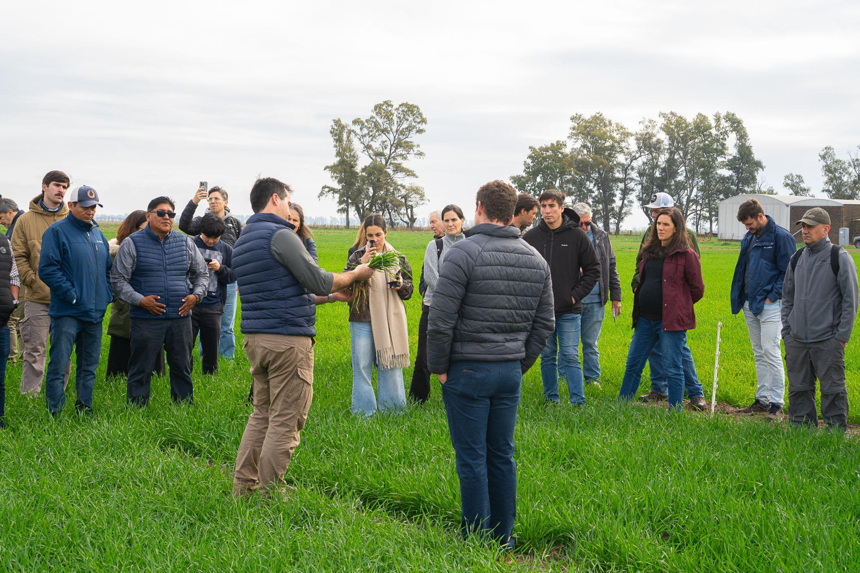
From March 7 to 13, 2027, Aapresid invites you to discover Argentina’s agroindustrial sector firsthand through the 2027 Agronomic Technical Tour: an experience designed for international delegations interested in exploring the country’s most innovative production systems up close.
Over the course of seven days, participants will tour leading agricultural operations, visit key companies and institutions within Argentina’s agro-industrial ecosystem, and gain access to cutting-edge technologies in machinery, inputs, and digitalization. The experience also includes participation in Expoagro, the largest open-air agro-industrial trade show in Latin America.

The tour showcases high‑performance production models based on soil conservation, efficient resource use, and collaboration among producers, technicians, scientists, and organizations. Through technical field visits and dedicated exchange spaces, participants will gain access to practical and scalable solutions that have enabled Argentine agriculture to enhance its productivity, resilience, and sustainability in the face of global challenges.
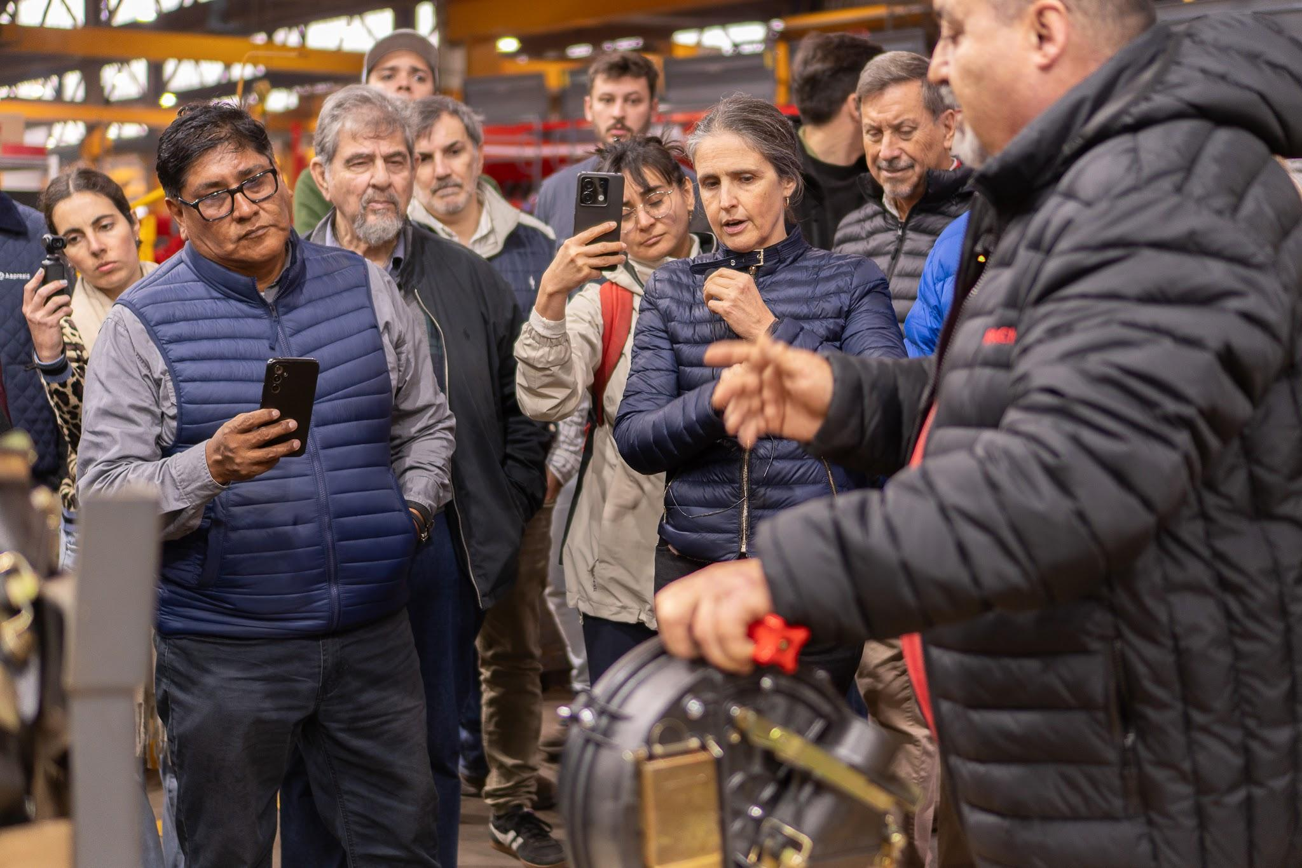
The itinerary includes:
- Visits to representative production farms across different regions of the country
- Technical meetings with farmers, advisors, and local experts from the Aapresid network
- Tours of leading companies in genetics, food industry, and technological services
- A full day in Rosario, the country’s main agro‑export hub
- Participation in Expoagro: the largest open-air agro-industrial trade show in Latin America.
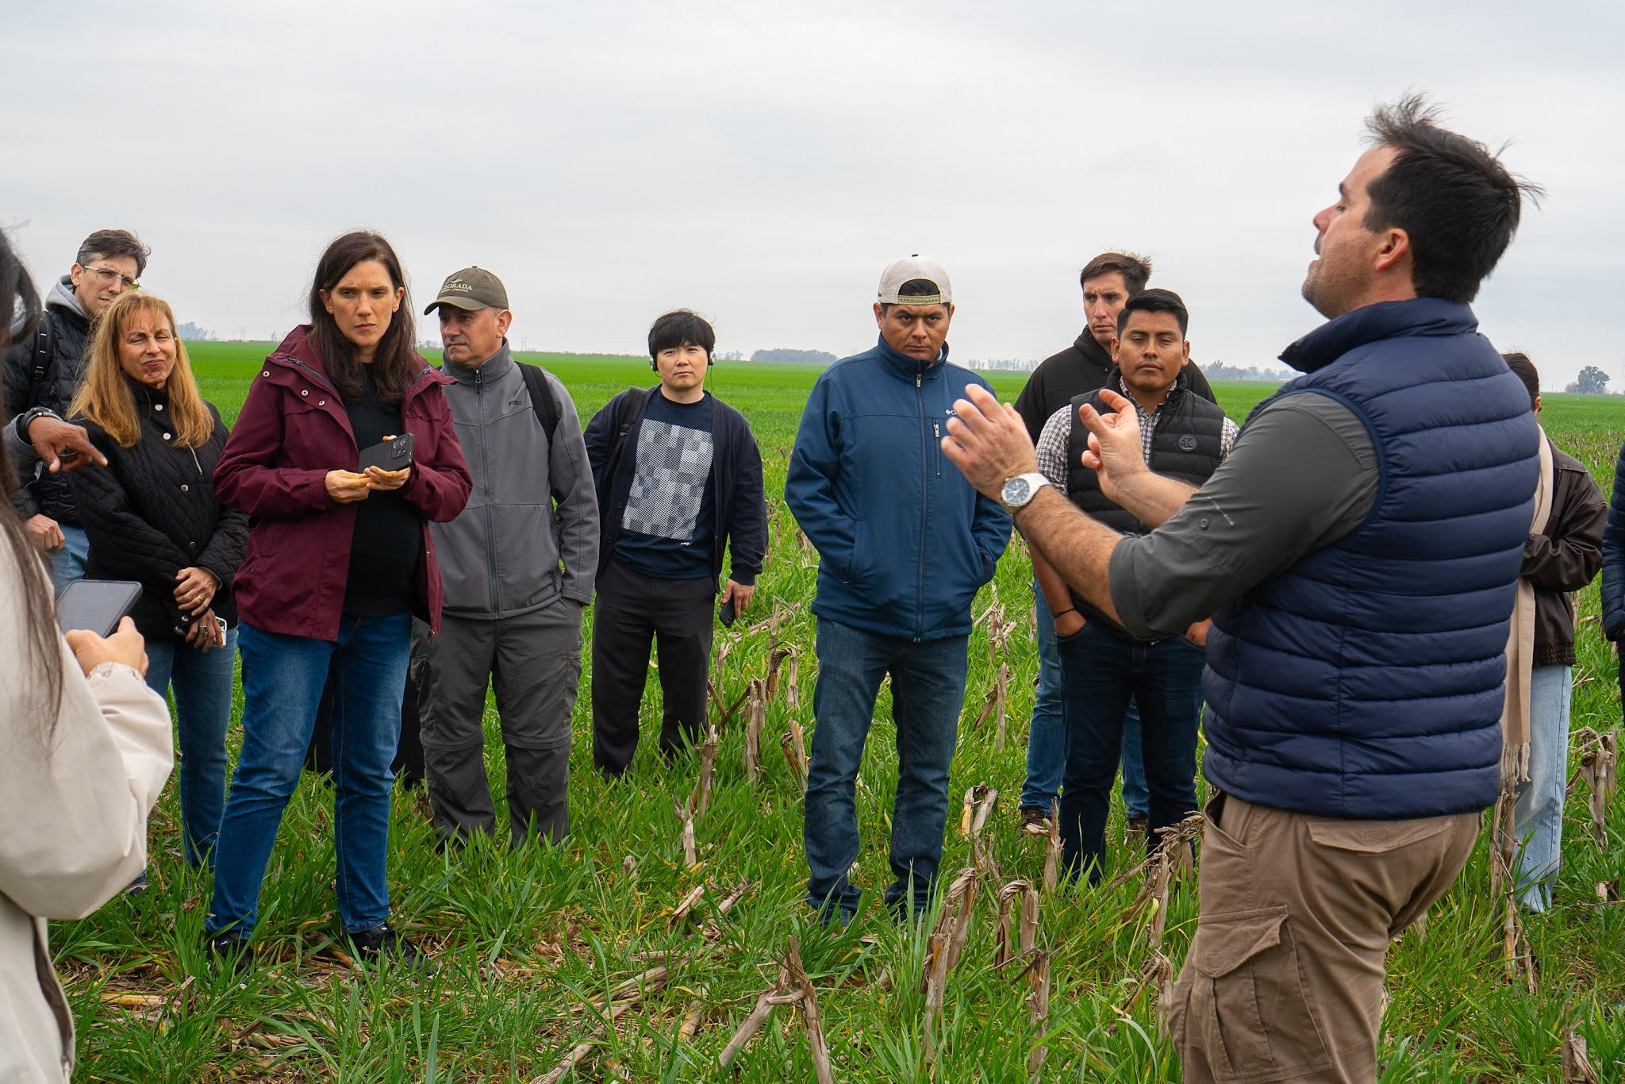
Designed for farmers , technicians, companies, universities, agricultural organizations, public officials, and international delegations, this tour offers a unique opportunity to build strategic connections, access cutting‑edge knowledge, and understand why Argentina is a global benchmark in large‑scale sustainable agriculture.
Download the full itinerary here.
Pack your bags and join this unique experience to discover, connect, and learn in the productive heart of Argentina!

